1ai)

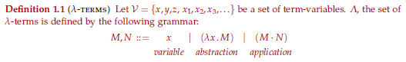

Beta reduction:



ii)



iii)

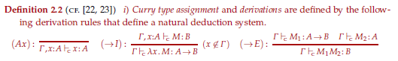

b)

To show:

M(YM) is beta equal to YM

Apply M to Y and beta reduce and you will get M(YM)

c)

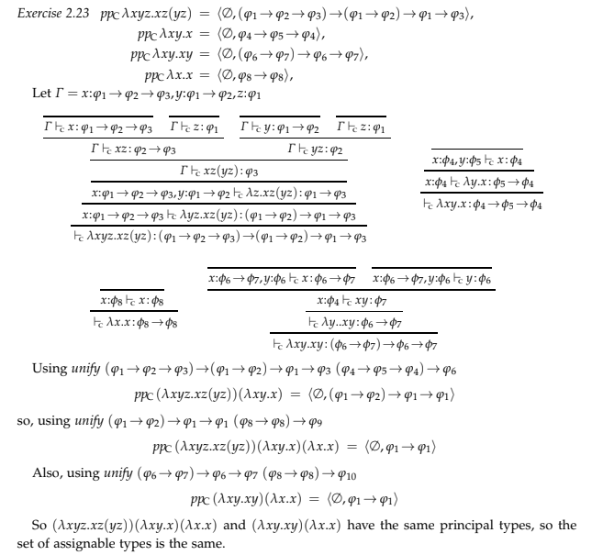

d)

No, it’s not possible to unify the types 1->2->1 and 1->1

2a)



b)

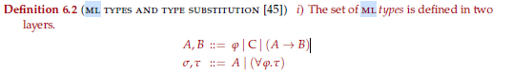

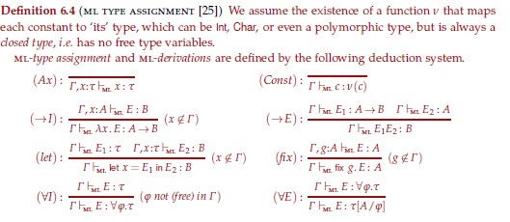

c) Van bakel (11/12/19 Q/A): It is the right one because it does not affect subject reduction. ???

He said something about “What is the desired property that we want for a fixed-point combinator”

PLEASE EXPLAIN IF SOMEONE CAN

d) Mycroft can type more terms but type assignment in his system is undecidable.

Mycroft also does not insist on typing recursive calls with the same type, all calls can be polymorphic

e)

Fix ts.λt. If (=[] t) then 0 else (+1 (+ ts(left t) ts(right t)))

3a)

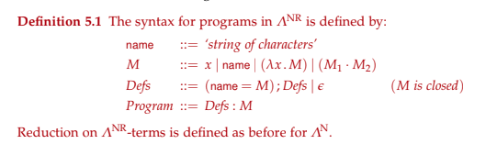

b)

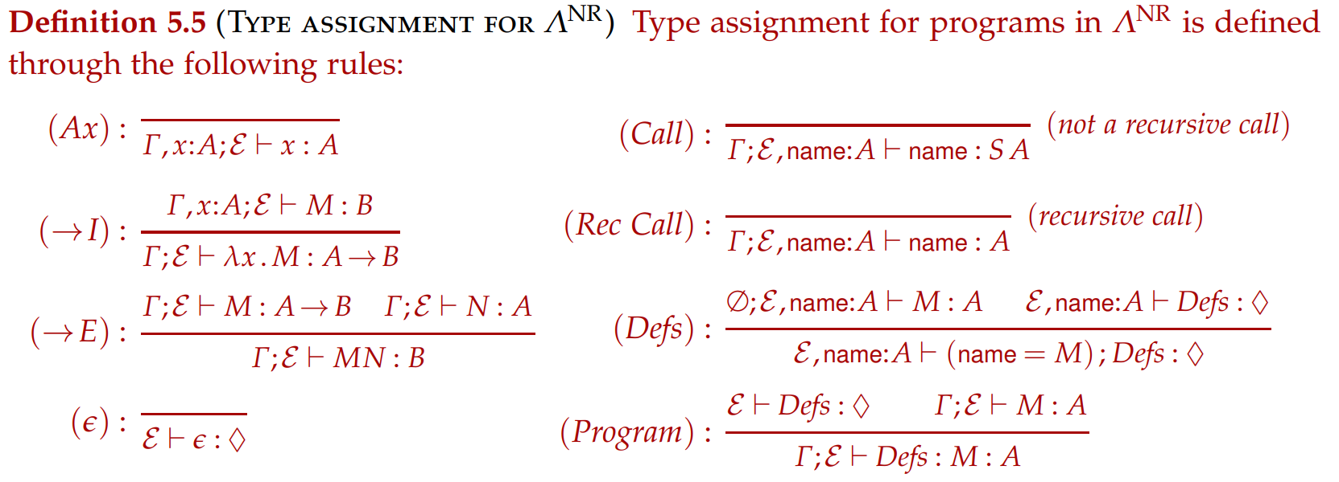

c)

See exercises

Y(SKK): 1

Where Y: (1 -> 1) -> 1

d)

wtf

4a)

i)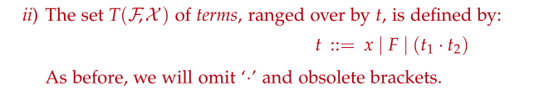

ii)

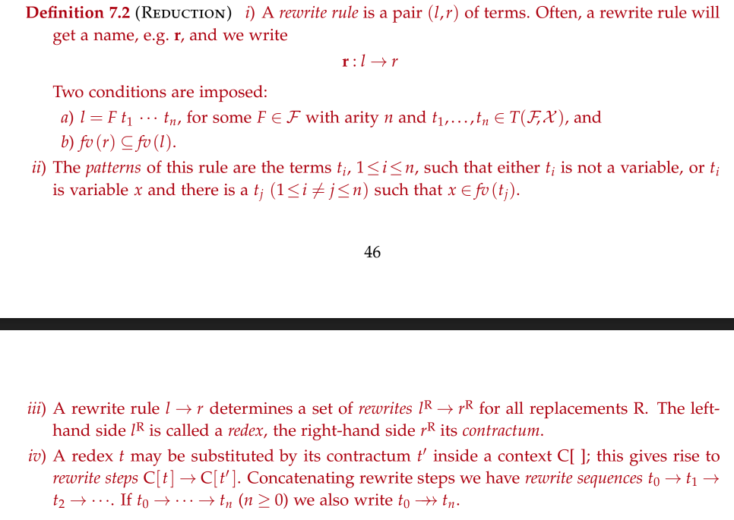

iii)

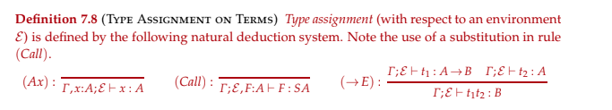

b)

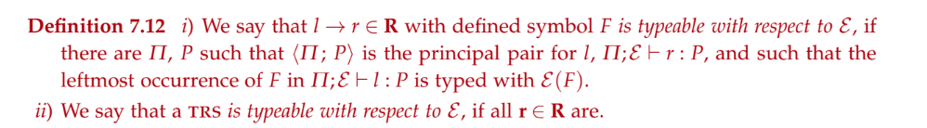

c) & d)

Exercise 7.21